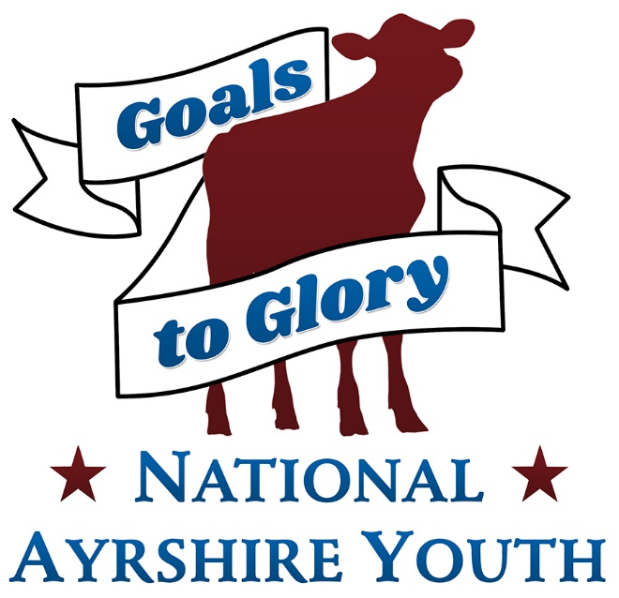
Photography Contest

Rules

- All entrants must be Junior Members of the Ayrshire Breeders’ Association.

- There will be four age divisions: (Ages as of January 1st of contest year)
•Senior: 16-21 •Intermediate: 13-15 •Junior: 9-12 •Beginner: 8 & under

- All pictures must have an Ayrshire affiliation.
The categories are: •Cute Calves •People & Cows •Around the farm •Selfie with an Ayrshire •Other

- Awards will be presented to the first place winner in each category, in each division.

- There will be one overall winner selected for Best of Show Photography.

- Each contestant may enter more than one photograph in each category, but there is a maximum of four photos per person in the contest.
- Photos & entry information including name, division & category should be emailed to info@usayrshire.com

- All Entries must be submitted by email by June 10th at midnight.

- By entering your photo you are allowing the Ayrshire Association to use your photo in Promotions.

Ayrshire Youth Photo Contest Judging Guidelines

Photo number:
Age Division:
Category:
---------------------------------------
Creativity-25 pts ____
Captures attention, Creative use of camera, tells a story to the viewer, Relevancy to the category

Composition-25 pts ____
Ayrshire Breed Related, Perspective enhances the image

Technical-25 pts ____
Sharp Focus, correct lighting (no obvious retouching or filters)

Impact - 25 pts ____
The feel one gets from a photo, does it create an emotion or empathy
Total ______

Judges Comments-

